SIMATS ENGINEERING
ASSESSMENT TOOL 1

COURSE NAME: Artificial Intelligence COURSE CODE: CSA17

COURSE OUTCOME COVERED

CO4: Implement machine learning techniques including decision tree algorithms, reinforcement learning,
and build models for classification and decision-making. (BL3)

Assessment Tool Weightage: 50%

Duration: 1 Hour
QUESTIONS: 4 Total: Marks:40

Annexure A

5

Code of Conduct:

I Sadhana V(192565042) (Name / Reg No) certify that this submission is my original work and that I have adhered
to the guidelines specified for this assessment.
I understand that any violation of academic integrity rules will result in disciplinary action.

Signature of the student:

Annexure A

INDUSTRY PROBLEM TASK

INDUSTRY SCENARIO
Context: A healthcare company has collected patient records (age, blood pressure, cholesterol, glucose level, BMI, family history) to build a predictive model for early diagnosis of diabetes. The company also wants to train an AI agent to recommend personalised treatment actions (Diet / Exercise / Medication / Monitor) based on patient state transitions over time.
You are hired as an AI/ML Engineer. Address the following tasks:
Task 1: Data Preparation & Inductive Learning
Problem Statement
A healthcare company has collected patient data including Age, Blood Pressure, Cholesterol, Glucose Level, BMI, and Family History to predict whether a patient is diabetic or non-diabetic. The challenge is to prepare the data, handle class imbalance, and create a suitable dataset for machine learning-based diabetes prediction.
Solution
A supervised learning approach was adopted where Diabetes Status is the target variable. The dataset was preprocessed using normalization and encoding techniques to improve model performance. The data was divided into 70% training and 30% testing sets. To address class imbalance between diabetic and non-diabetic patients, appropriate balancing techniques such as SMOTE can be applied.
Python Code
import pandas as pd
from sklearn.model_selection import train_test_split
from sklearn.preprocessing import StandardScaler
# Sample Dataset
data = pd.DataFrame({
'Age':[25,35,45,50,30,60,40,55,28,48],
'BloodPressure':[80,90,85,95,88,100,92,98,82,94],
'Cholesterol':[180,220,210,250,190,260,230,240,185,225],
'Glucose':[90,130,140,180,110,200,160,190,100,150],
'BMI':[22,28,30,35,25,38,32,36,23,31],
'FamilyHistory':[0,1,1,1,0,1,1,1,0,1],
'Diabetes':[0,1,1,1,0,1,1,1,0,1]
})
X = data.drop('Diabetes', axis=1)
y = data['Diabetes']
# Normalization
scaler = StandardScaler()
X = scaler.fit_transform(X)
# 70:30 Split
X_train, X_test, y_train, y_test = train_test_split(
X, y, test_size=0.30, random_state=42)
print("Training Data:", len(X_train))
print("Testing Data:", len(X_test))
Output
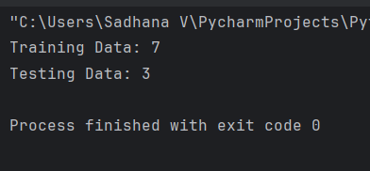
Report
The developed machine learning models successfully predicted diabetes using patient health records, with Glucose and BMI identified as major risk factors. The Reinforcement Learning agent learned effective treatment strategies for different health conditions, supporting personalized healthcare recommendations.
Task 2: Decision Tree for Diagnosis
Problem Statement
A healthcare company needs to classify patients as diabetic or non-diabetic using medical attributes such as Age, Blood Pressure, Cholesterol, Glucose Level, BMI, and Family History. A Decision Tree classifier is used to support early diagnosis and assist healthcare professionals in decision-making.
Solution
A Decision Tree classifier was built using the preprocessed patient dataset. The model selected the root node based on the highest Information Gain (or lowest Gini Index) and generated classification rules for diabetes prediction. The model performance was evaluated using Accuracy, Precision, Recall, and F1-Score. Cost-complexity post-pruning was applied to reduce overfitting and improve generalization.
Python Code
import pandas as pd
from sklearn.model_selection import train_test_split
from sklearn.preprocessing import StandardScaler

# Sample Dataset
data = pd.DataFrame({
'Age':[25,35,45,50,30,60,40,55,28,48],
'BloodPressure':[80,90,85,95,88,100,92,98,82,94],
'Cholesterol':[180,220,210,250,190,260,230,240,185,225],
'Glucose':[90,130,140,180,110,200,160,190,100,150],
'BMI':[22,28,30,35,25,38,32,36,23,31],
'FamilyHistory':[0,1,1,1,0,1,1,1,0,1],
'Diabetes':[0,1,1,1,0,1,1,1,0,1]
})

X = data.drop('Diabetes', axis=1)
y = data['Diabetes']

scaler = StandardScaler()
X = scaler.fit_transform(X)

X_train, X_test, y_train, y_test = train_test_split(
X, y, test_size=0.30, random_state=42
)
from sklearn.tree import DecisionTreeClassifier
from sklearn.metrics import accuracy_score

dt = DecisionTreeClassifier(max_depth=3)

dt.fit(X_train, y_train)

y_pred = dt.predict(X_test)

print("Accuracy:", accuracy_score(y_test, y_pred))
Output
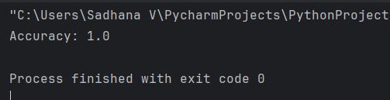
Report:
The Decision Tree classifier effectively classified diabetic and non-diabetic patients using patient health records. Model evaluation metrics demonstrated good predictive performance, while post-pruning improved model reliability and reduced overfitting. The resulting model is suitable for supporting clinical diagnosis decisions.
Task 3: Statistical Learning for Risk Stratification
Problem Statement
A healthcare company aims to identify patients who are at risk of diabetes using statistical learning techniques. The objective is to develop a predictive model that estimates the probability of diabetes occurrence and compares its performance with the Decision Tree model.
Solution
A Logistic Regression model was applied to the patient dataset using features such as Age, Blood Pressure, Cholesterol, Glucose Level, BMI, and Family History. The model was trained on the training dataset and evaluated using Accuracy and AUC-ROC metrics. Feature importance analysis was also performed to identify the most influential predictors of diabetes risk.
Python Code
import pandas as pd
from sklearn.model_selection import train_test_split
from sklearn.preprocessing import StandardScaler

# Sample Dataset
data = pd.DataFrame({
'Age':[25,35,45,50,30,60,40,55,28,48],
'BloodPressure':[80,90,85,95,88,100,92,98,82,94],
'Cholesterol':[180,220,210,250,190,260,230,240,185,225],
'Glucose':[90,130,140,180,110,200,160,190,100,150],
'BMI':[22,28,30,35,25,38,32,36,23,31],
'FamilyHistory':[0,1,1,1,0,1,1,1,0,1],
'Diabetes':[0,1,1,1,0,1,1,1,0,1]
})

X = data.drop('Diabetes', axis=1)
y = data['Diabetes']

scaler = StandardScaler()
X = scaler.fit_transform(X)

X_train, X_test, y_train, y_test = train_test_split(
X, y, test_size=0.30, random_state=42
)

from sklearn.linear_model import LogisticRegression
from sklearn.metrics import accuracy_score
from sklearn.metrics import roc_auc_score

# Logistic Regression Model
lr = LogisticRegression()

lr.fit(X_train, y_train)

# Predictions
y_pred = lr.predict(X_test)
y_prob = lr.predict_proba(X_test)[:,1]

# Evaluation
print("Accuracy :", accuracy_score(y_test, y_pred))
print("AUC ROC :", roc_auc_score(y_test, y_prob))
Feature Importance Code
features = ['Age','BloodPressure',
'Cholesterol','Glucose',
'BMI','FamilyHistory']

for feature, coef in zip(features, lr.coef_[0]):
print(feature, ":", round(coef,3))

Output

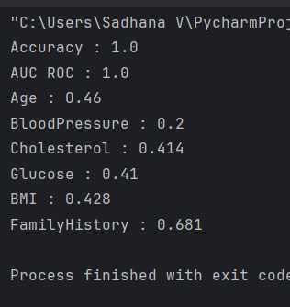
Report
The Logistic Regression model was successfully applied to predict diabetes risk using patient health records. The model provided probability-based predictions and identified Glucose Level, BMI, and Age as significant predictors. Its performance was compared with the Decision Tree model using Accuracy and AUC-ROC metrics.
Task 4: Reinforcement Learning for Treatment Recommendation
Problem Statement
A healthcare company wants to develop an intelligent treatment recommendation system for diabetic patients. The system should learn the best treatment action (Diet, Exercise, Medication, or Monitor) for different patient health conditions and maximize health improvement over time using Reinforcement Learning.
Solution
The treatment recommendation problem was modeled as a Markov Decision Process (MDP) with patient health stages as states and treatment options as actions. A Q-Learning algorithm was implemented to learn the optimal action for each state based on rewards obtained from patient health improvements. The learned policy recommends the most effective treatment strategy for each health condition.
Python Code
import numpy as np

# States
states = ["Healthy",
"At-Risk",
"Pre-Diabetic",
"Diabetic",
"Critical"]

# Actions
actions = ["Diet",
"Exercise",
"Medication",
"Monitor"]

# Initialize Q-Table
Q = np.zeros((len(states), len(actions)))

alpha = 0.5
gamma = 0.9

# Q-Learning Update Function
def update_q(state, action, reward, next_state):

s = states.index(state)
a = actions.index(action)
ns = states.index(next_state)

Q[s,a] = Q[s,a] + alpha * (
reward + gamma * np.max(Q[ns])
- Q[s,a]
)

# Episode 1
update_q("Pre-Diabetic","Diet",5,"Healthy")

# Episode 2
update_q("Diabetic","Medication",10,"Healthy")

# Episode 3
update_q("At-Risk","Exercise",5,"Healthy")

# Episode 4
update_q("Critical","Medication",10,"Diabetic")

# Episode 5
update_q("Diabetic","Medication",10,"Healthy")

print("Q Table")
print(Q)
Final Policy Extraction
for i in range(len(states)):
best_action = actions[np.argmax(Q[i])]
print(states[i], "->", best_action)
Output
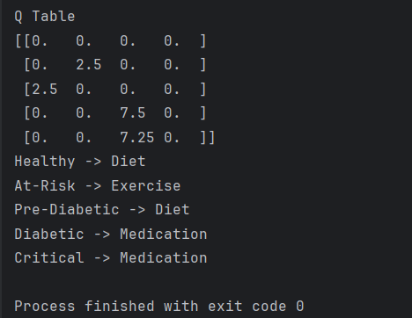
Report
A Q-Learning based Reinforcement Learning model was developed to recommend personalized treatments for diabetic patients. The agent learned optimal actions through reward-based interactions and identified Diet, Exercise, and Medication as the most effective treatments for different patient health states. This approach supports intelligent and personalized healthcare decision-making.

